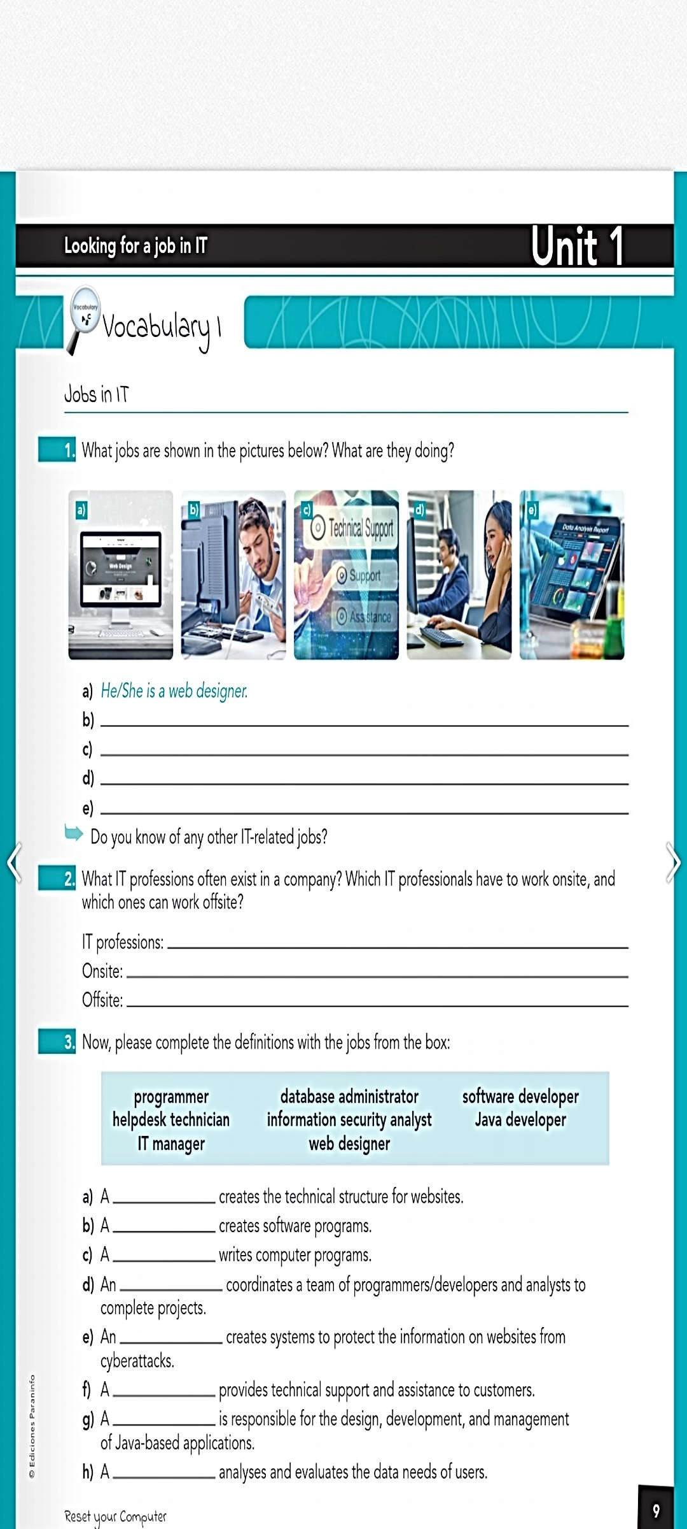
Hes conecting a router, he maybe its a profesional in telecomunicacions
Hes a technical support
They are working in vodafone and do the calls to do offers to the people
Hes a laboratory technical
Software developer, programer, technical assistant. Grafical designer, Especialist Cibersegurity, Especialist in IA
Software developer, technical assistant, Grafical designer,Especialist in IA
Software developer, programer, technical assistant. Grafical designer, Especialist Cibersegurity, Especialist in IA
Web designer
Software developer
Programmer
Database administrator
Information security analyst
Helpdesk thnician
Java developer
IT manager
